Adventures with Purpose--
Geneva & the Matterhorn

“Quest for the Water Castle”

Richard Bangs’ Adventures with Purpose—Geneva and the Matterhorn, a new one-hour special from American Public Television, will air on _________ (station) _________________ at (time) _______, (day) __________ (date) _________. Hosted by Richard Bangs who is often called “the father of modern adventure travel,” Geneva and the Matterhorn: Quest for the Water Castle is the latest documentary in a series of adventure travel, eco-conscience, and historical specials. According to Bangs, “Adventures with Purpose not only quicken the pulse and fire the synapses, they are also journeys of enlightenment and discovery—odysseys that make a difference.”
Adventures with Purpose is produced by Small World Productions of Seattle. The hour-long documentary specials are co-produced by KCTS/Seattle, and Richard Bangs Productions of Marina del Rey, California. KCTS is the presenting station to APT-Exchange, the national distributor.

This time adventurer Richard Bangs’ voyage takes him up one of the world’s great rivers—the Rhone—a waterway that spills from the roof of the European continent, bringing health, wealth, pleasure and inspiration. A vital source of life, it’s a river that lights cities, powers the world’s best rail systems, and slakes the thirst of millions.

In Quest for the Water Castle Richard explores the Geneva and Matterhorn Region of Switzerland to find out what bounty the Rhone has bestowed to the country and to the world. He seeks to learn how the river has been harnessed, explored and celebrated.

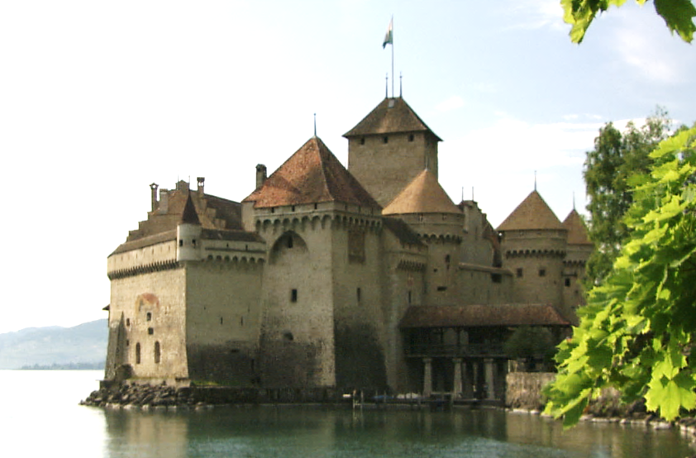
According to Bangs, water is over-tapped and under-tended in many places around the world but not in Switzerland. How has this alpine haven—Europe’s water castle—resisted temptation to bleed its most precious resource?

Six percent of the continent’s fresh reserves of water are found in the mountain refuges of Switzerland. Bangs is off to find how the Swiss became such bold curators of water resources and to catch what lessons they’ve learned.

The mighty Rhone spills into Western Europe’s largest natural lake. Known as Lac Leman to the French and Lake Geneva to the English, good people have marveled at ‘a-sea-of-a-lake’ and its embrace of sky-scratching peaks since Roman times.

Water has the velocity and weight to influence the course of entire communities, societies, states. It has the power to move mountains. Richard calls it “a paean to peace, and a cause of war.” He observes that “everyone everywhere requires it.”

Virile and resolute, the Rhone takes a nap beneath the Alps in Lake Geneva before it fetches up the sea. We learn that the water of the lake provides endless recreation, nurtures the vineyards above its banks, and provisions the kitchens that line its shores.

Of the scenery at Lake Geneva, the poet Lord Byron penned “I saw their thousand years of snow/ On high-their wide long lake below/ And the blue Rhone in fullest flow.”
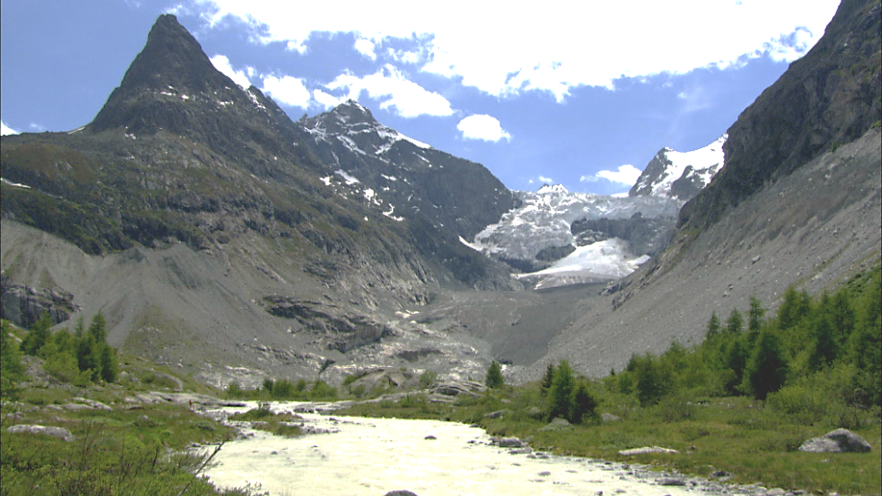
Richard’s journey begins in multicultural, affluent and hardworking Geneva, a financial powerhouse and home to the UN European Headquarters, The Red Cross and the World Health Organization. His trip takes him along the shores of the lake to the towns of Nyon, Lausanne, and Vevey. After a stop at well-preserved Chateau Chillon, built in the 12th century near the end of the lake to control traffic along the Rhone, Richard climbs through the great Rhone Valley high to the wellspring of the river in the pristine peaks of the Uri Alps. His destinations include: the Valais—French for ‘the valley’; the spa town of Leukerbad and its towering peaks; Zermatt and the Matterhorn; Fiesch and nearby mountain villages; and finally to the Aletsch Glacier.

Host and co-executive producer, Richard Bangs is a pioneer in travel that makes a difference, travel with a purpose. He has spent more than 30 years as an explorer and communicator, and along the way led first descents of 35 rivers around the globe, including the Yangtze in China and the Zambezi in Southern Africa. Richard has published more than 1000 magazine articles, 18 books, a score of documentaries and CD-ROMs; and has lectured at the Smithsonian, the National Geographic Society, the Explorers Club and many other notable venues. He writes feature articles for the Huffington Post. His latest books include Adventures with Purpose, Quest for Kaitiakitanga, Quest for the Sublime and Quest for the Kasbah, companion books for episodes in the television series.

Richard’s books and DVDs of Adventures with Purpose—Geneva and the Matterhorn: Quest for the Water Castle are available from Small World Productions. Each DVD contains the complete show and more than an hour of value-added bonuses including never-before-seen footage, and behind-the-scenes glimpses. DVDs are $24.95 each plus shipping. Richard’s Adventures with Purpose books are $16.95 each plus shipping. Books include essays by Richard on a number of destinations. The book and DVD together are $35.95 plus shipping. Viewers may order online at www.AdventuresWithPurpose.TV or call the order desk at 800.866.7425.
Adventures with Purpose—Geneva and the Matterhorn: Quest for the Water Castle will be up-linked on APT’s HD satellite transponder. HD and standard definition “letterboxed” versions of the documentary will air on hundreds of public TV stations nationwide. Digital audio is transmitted in stereo.

Adventures with Purpose--
Geneva & the Matterhorn

American Public Television (APT) has been a leading distributor of high-quality, top-rated programming to America’s public television stations since 1961. Since 2004, APT has distributed approximately half of the top 100 highest-rated public television titles. Among its 300 new program titles per year are prominent documentaries, news and current affairs programs, dramatic series, how-to programs, children’s series and classic movies, including For Love of Liberty: The Story of America’s Black Patriots, A Ripple of Hope, Rick Steves' Europe, Newsline, Globe Trekker, Simply Ming, Travelscope, America's Test Kitchen From Cook’s Illustrated, Lidia's Italy, P. Allen Smith's Garden Home, Murdoch Mysteries, Doc Martin, Rosemary & Thyme, The Rat Pack: Live and Swingin’, Johnny Mathis: Wonderful, Wonderful! and John Denver: The Wildlife Concert. APT also licenses programs internationally through its APT Worldwide service. In 2006, APT launched and nationally distributed Create® – the TV channel featuring the best of public television's lifestyle programming. APT is also a partner in the WORLD™ channel expansion project including its web presence at WORLDcompass.org. For more information about APT’s programs and services, visit APTonline.org. For more information on Create, visit CreateTV.com.

Richard Bangs’ Adventures with Purpose
Geneva and the Matterhorn: Quest for the Water Castle

Co-produced by
| Small World Productions | KCTS/ Seattle |Richard Bangs Productions |

Small World Productions | 140 Lakeside Avenue | Suite 200 | Seattle WA 98122 |
|www.AdventuresWithPurpose.TV | 206 329 7167 | johngivens@travelsmallworld.com |

